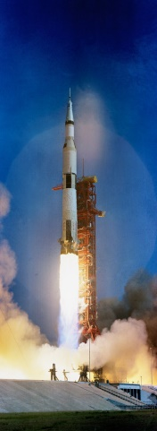**Merryn’s History Timeline**

In 1969 Apollo 11 successfully travelled to the moon. Neil Armstrong was the first man to walk on the moon.

The first railway steam engine that was successful was invented by George Stephenson in 1802. It was also the first to carry people.

The battle of Naseby was between King Charles and Oliver Cromwell. It was fought just near the village of Naseby and took place in 1645. The armies were called the Roundheads and the Cavaliers. Cromwell’s army won the battle.

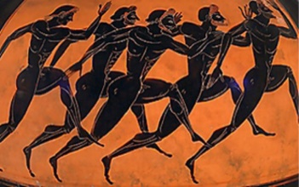

The Black Death (also known as the plague) killed up to 200 million people in North Africa and Eurasia in 1347.

The first Olympics were held in Olympia in Greece in 776 BC

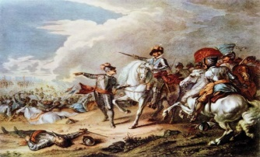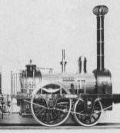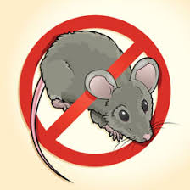

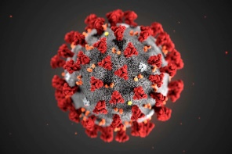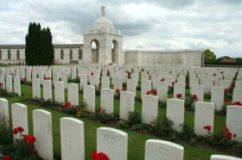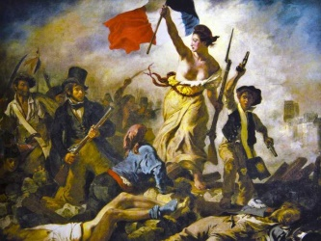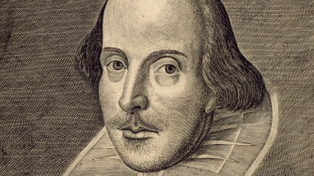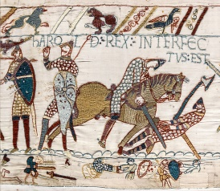

In 2019 a new strain of flu started in China and started to spread around the world. Schools closed so children are doing their school work from home to stay safe.

The First World War lasted for 4 years and lots of brave soldiers fought to make a better future. Lots of countries were joining the fight against Germany in 1914.

The Battle of Hastings was fought by The French army of William, the Duke of Normandy and the English army under the Anglo-Saxon King Harold Godwinson, beginning the Norman conquest of England in 1066

The French Revolution was a time when people didn’t like the monarchy so they threw them out in 1789. This lasted for 10 years.

William Shakespeare was born in 1564 but we are not sure exactly what date. We do know he was baptized on the 26 of April and you usually are baptized 3 days after your birthday. Shakespeare went on to write some of the most famous plays ever written.