You looked at Medusa too long miss a turn

NO.5

NO.4

You have a message from Iris move forward 2 spaces

NO.2

START

NO.9

You have made it to Jason’s thrown, move forward 3 spaces

NO.11

NO.12

You have been smited by Zues go back 3 spaces

NO.7

NO.18

Sorry Aphrodite thinks your ugly, move back 5 spaces

No 16

NO.15

NO.14

You pleased Cronus, move 4 spaces : )

NO.25

Athena is impressed with your skills move 2 spaces

NO.22

NO. 21

You have disappointed Tartarus he throws you in to the abyss go back 5 spaces

NO.19

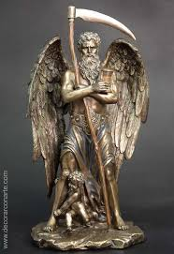

FINISH

Hypnose likes your ability to sleep, move forward 1 space

NO. 28

NO. 27

Hermes has punished you for srealing go back 3 spaces

[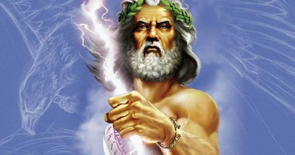](https://www.google.com/url?sa=i&url=https://www.ancient-origins.net/myths-legends-europe/unshakeable-power-zeus-prime-mover-ancient-greek-deities-008806&psig=AOvVaw3Td94znoy4mHd0ksn3ja9K&ust=1588255544677000&source=images&cd=vfe&ved=0CAIQjRxqFwoTCJD_g4_njekCFQAAAAAdAAAAABAF)

You reached the end. The gods and goddesses are pleased well done!!!!!!!



[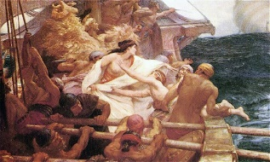](https://www.google.com/url?sa=i&url=http://www.argonauts-book.com/berens-summary.html&psig=AOvVaw2ltdn0JLnNWtHqHLsReXDZ&ust=1588256036848000&source=images&cd=vfe&ved=0CAIQjRxqFwoTCNDX1fnojekCFQAAAAAdAAAAABAE)

[](https://www.google.com/url?sa=i&url=https://www.greekboston.com/culture/mythology/all-about-aphrodite/&psig=AOvVaw1wC7yFxqTZzMuVMxNgutlU&ust=1588256408629000&source=images&cd=vfe&ved=0CAIQjRxqFwoTCLDm-qrqjekCFQAAAAAdAAAAABAE)[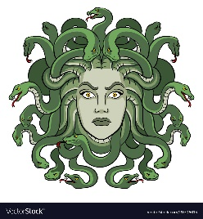](https://www.google.com/url?sa=i&url=https://www.vectorstock.com/royalty-free-vector/medusa-greek-myth-creature-pop-art-vector-20706013&psig=AOvVaw2aZCF0Q7x82fByl-po6NH4&ust=1588255713808000&source=images&cd=vfe&ved=0CAIQjRxqFwoTCJCJ3t_njekCFQAAAAAdAAAAABAE)

[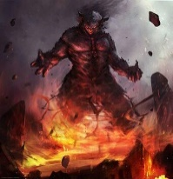](https://www.google.com/url?sa=i&url=https://the-demonic-paradise.fandom.com/wiki/Tartarus_(God)&psig=AOvVaw3ibu0YuCMG4wBoLujl-Mkh&ust=1588256625981000&source=images&cd=vfe&ved=0CAIQjRxqFwoTCMCKy5LrjekCFQAAAAAdAAAAABAE)