Naseby Primary Academy - Science
Topic: Animals Including Humans and the Heart | Year 5/6

What should I already know? |  |  |  | Diagram - The Circulatory System
- the function of the skeleton and the purpose of muscles;  - the basic parts of the digestive system and the functions of organs in this system;  - the different types of teeth in humans and their functions;  - the life cycle of a human and how we change as we grow and develop;  - the basic needs of animals for survival (water, food, air);  - the importance of exercise, hygiene and a balanced diet. |  |  |  | 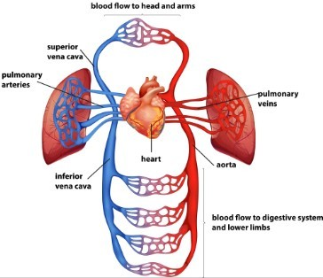  - The right atrium collects the deoxygenated blood from the body, via the vena cava. It sends the blood to the right ventricle.  - The right ventricle pumps the deoxygenated blood to the lungs. Here the blood picks up oxygen and disposes of carbon dioxide.  - The lungs send oxygenated blood back to the left atrium which pumps it to the left ventricle.  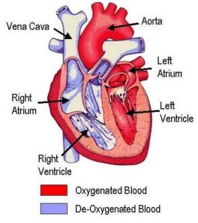  - The left ventricle pumps the blood to the rest of the body, via the aorta.  - The heart is composed of  four chambers; the right atrium, the right ventricle,  the left atrium and the left ventricle.  How often your heart pumps is called your pulse.
Scientific Learning
What is the Circulatory System?  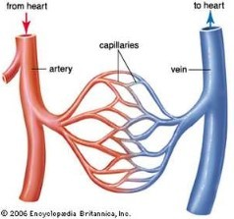 | - The circulatory system is made of the heart, lungs and blood vessels  - Arteries carry oxygenated blood from the heart to the rest of the body.  - Veins carry deoxygenated blood from the body to the heart.  - Nutrients, oxygen and carbon dioxide are exchanged via the capillaries.
Choices that can harm the circulatory system. | - Some choices, such as smoking and drinking alcohol can be harmful to our health.  - Tobacco can cause short-term effects such as shortness of breath, difficulty sleeping and loss of taste and long-term effects such as lung disease, cancer and death.  - Alcohol can cause short-term effects such as addiction and loss of control and long-term.  - Effects such as organ damage, cancer and death.
Why is exercise so important? | Exercise can:  - tone our muscles and reduce fat;  - increase fitness;  - make you feel physically and mentally healthier;  - strengthen the heart;  - improve your lung function;  - improve your skin. |  |  | What I should know by the end of the unit.
- How my pulse changes with exercise and the most efficient way of presenting this data.
- The four parts of my blood and the job of each of these parts.
- The names of the four chambers of the heart.
- How my heart works.
- How blood travels around my body.
- The effect exercise has on my heart.
- The effect food, drugs and alcohol have on my body.
- The way in which water and nutrients are transported around my body.

aorta the main artery through which blood leaves your  heart before it flows through the rest of your body  artery a tube in your body that carries oxygenated blood  from your heart to the rest of your body  atrium one of the chambers in the heart  blood vessels the narrow tubes through which your blood flows.  arteries, veins and capillaries are blood vessels  capillaries tiny blood vessels in your body  carbon dioxide a gas produced by animals and people breathing out  circulatory the system responsible for circulating blood through  system the body, that supplies nutrients and oxygen to the body and removes waste products such as carbon  dioxide  deoxygenated blood that does not contain oxygen  heart the organ in your chest that pumps the blood around  your body  lungs two organs inside your chest which fill with air when you breathe in. They oxygenate the blood and remove  carbon dioxide from it |  |  | nutrients substances that help plants and animals to grow  organ a part of your body that has a particular purpose  oxygen a colourless gas that plants and animals need to survive  oxygenated blood that contains oxygen  pulse the regular beating of blood through your body. How fast or slow your pulse is depends on the activity you  are doing  respiration process of respiring; breathing ; inhaling and exhaling air. In KS3 Science, this process is referred to as  ventilation  veins a tube in your body that carries deoxygenated blood  to your heart from the rest of your body  vena cava a large vein through which deoxygenated blood  reaches your heart from the body  ventilation the exchange of air between the lungs and the atmosphere so that oxygen can be exchanged for  carbon dioxide  ventricle one of the chambers in the heart  via through

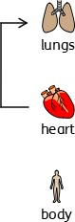
4
1
3
2
Question 7: Explain what is happening at each stage of the process.

Question 5: The veins carry  ………….. blood. | Start of unit: | End of unit:
deoxygenated
oxygenated
blue

Question 9: The function of the blood is to provide the body with…(tick three) | Start of unit: | End of unit:
nutrients
water
carbon dioxide
oxygen

Question 8: Which of these can harm our bodies? Tick two. | Start of  unit: | End  of  unit:
smoking
all drugs
alcohol
exercise

Question 10: Arteries, veins  and capillaries are examples of… | Start of  unit: | End  of  unit:
blood
blood vessels
blood types
nutrients

Question 6: Tick two boxes  below to show the two  activities that would increase pulse rate the most. | Start of  unit: | End  of  unit:
reading a book
playing football
drinking water
going for a walk

Question 4: You are  investigating which exercise yields the highest heart rate. How can you ensure a fair test? Tick two. | Start of unit: | End of unit:
treat everybody the same
measure the same subject’s pulse before, during and after each exercise.
ensure the starting heart rate is the same before each exercise
complete each exercise
without resting in between.

Question 3: The most effective way to show the change in pulse rate over time is by using a... | Start of unit: | End of unit:
picture
bar chart
pie chart
line graph

Question 2: Which one of these is not an organ? | Start of  unit: | End of  unit:
heart
lungs
blood

Question 1: The heart, blood  vessels and lungs make up the… | Start of unit: | End of unit:
digestive system
circulatory system
skeletal system
muscular system

