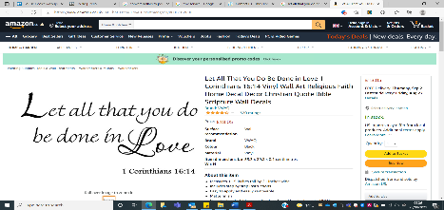
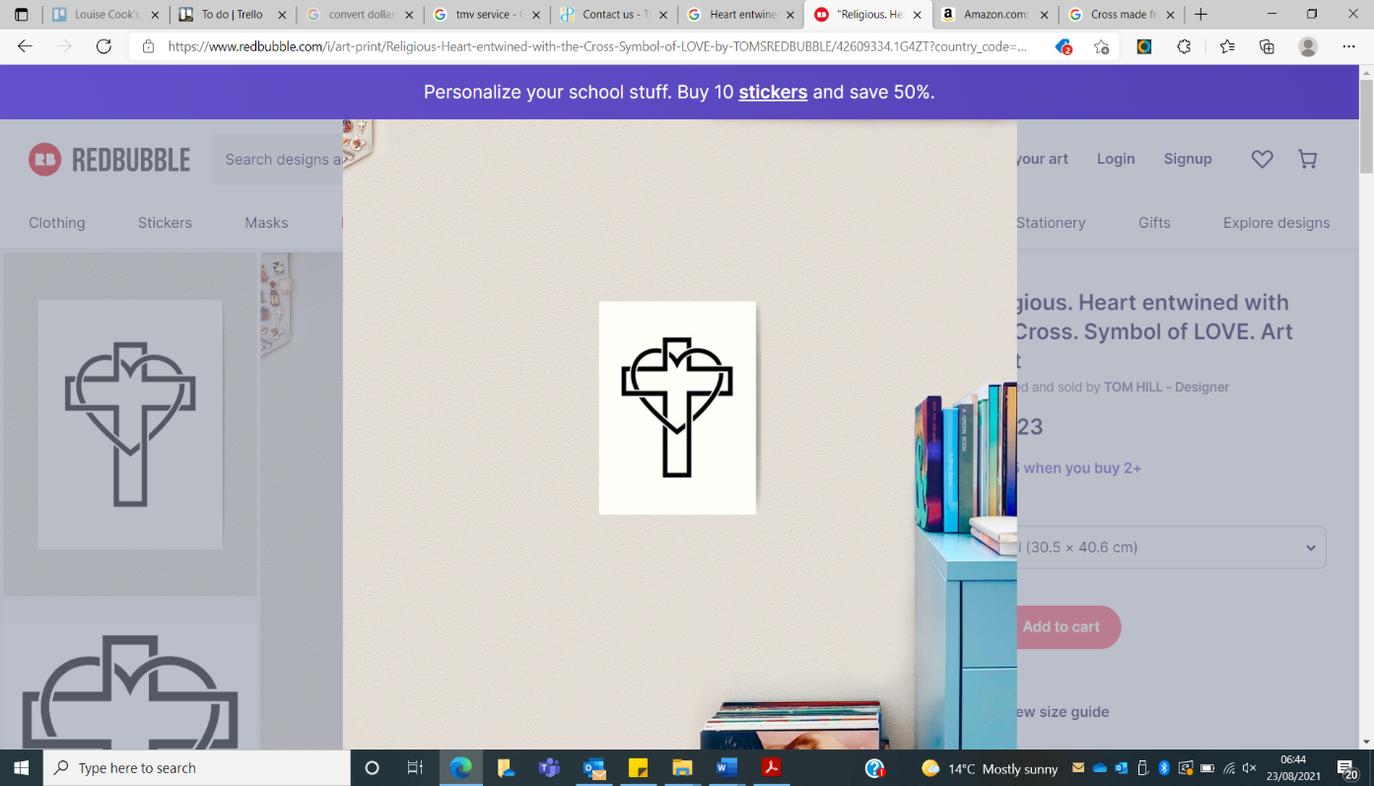
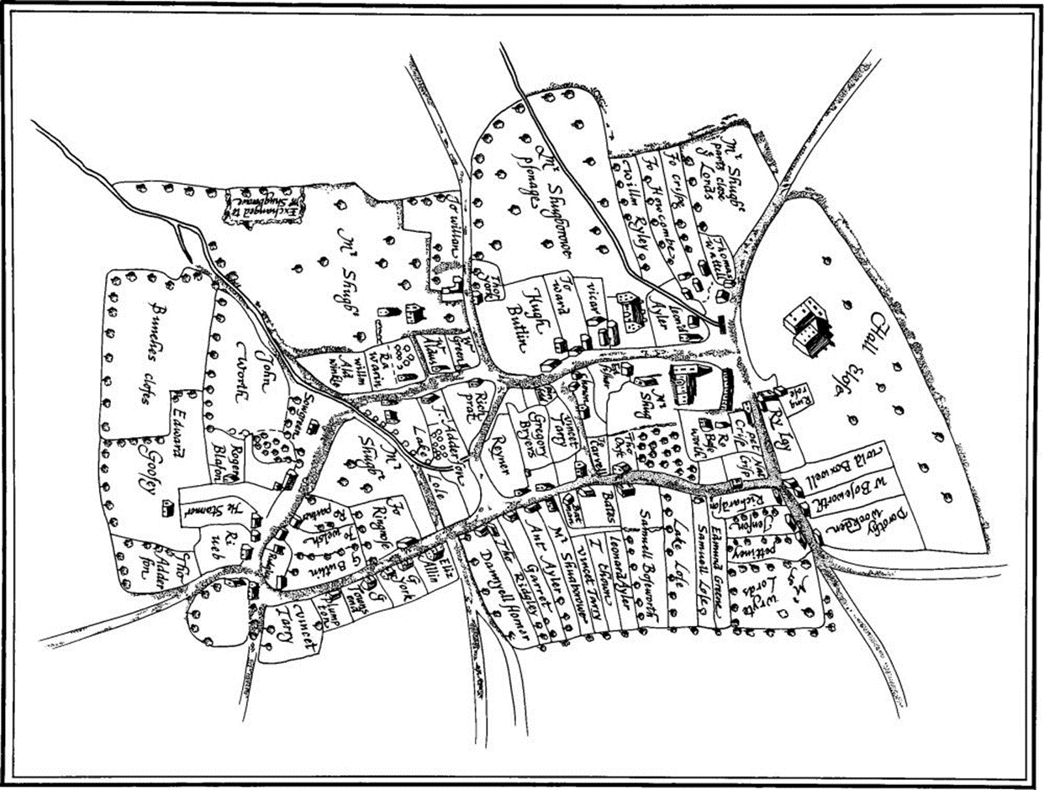
180th Anniversary of Naseby School
Key Vocabulary

Locality – A neighbourhood or area.
Significant – Something or someone very important.
Community – A group of people who live in the same area or who have something in common.
Heritage – The history and traditions of a particular area or culture that are significant today.

Key People
King Charles
King John
Fitzgeralds, Lord of the Manor
Princess Elizabeth
Timeline of Key Events
1203 – Market Charted Granted 1646 - The Battle of Naseby 1720-1785 - Georgian buildings were added
1843 - Naseby School Started 1948 - Naseby Hall Fire
In this Unit children will:
I can chronologically order historical events.
I can create a timeline of local events.
I can compare maps of a local area, through different years.
I can sketch a local building.
I can demonstrate my knowledge an understanding .about Naseby.
Background Information
In this terms topic we are doing a local study of Naseby. Firstly, we are looking at creating our own timeline of the historical events that happened in Naseby. Then we will be investigating how the village has change through out the years by look at a range of maps from different time points and comparing the similarities and differences.
Key facts
Naseby was a thriving market town in the early Middle Ages, with a market charter granted by King John in 1203. The present church dates from the early 13th century. The South aisle was added to the Saxon church in 1232, and the present nave and North aisle added over the next 75 years. In the 20th century, the Hall hosted the Duke of York, later King George V, with his Duchess (The Queen Mother) and a very young future Queen Elizabeth.
Transferable vocabulary & concepts
Comparing – during this topic we will be comparing different time periods and identifying similarities and difference.
development – We will looking how villages develop over time and why.

