**Art and Design**

This term Year 1 and 2 will be looking at examples of artwork depicting icebergs. They will also be exploring the ways in which they can design a boat that floats.

**Religious Education  
What does it mean to be a Sikh in Britain today?**  
We will be looking at the traditions of Sikhism and the routines and rituals that they partake in.

**Computing**

We will be beginning to use writing programmes to show the information we have learned from our topic.

**English**

This term Year 1 and 2 will be exploring the features of diary entries and will be reading the books ‘Samson’s Titanic Journey’ and ‘Kaspar: Prince of Cats’.

**Maths**  
This term we will be furthering our addition and subtraction knowledge and developing our multiplication and division skills. We will also be applying our place value expertise when solving problems.

**Science, Geography and History**  
We will be using our detective skills to discover information about the Titanic and the varying experiences that different passengers were exposed to. We will also be discussing what we can learn from those who helped during the aftermath of the sinking and how we can learn from it.

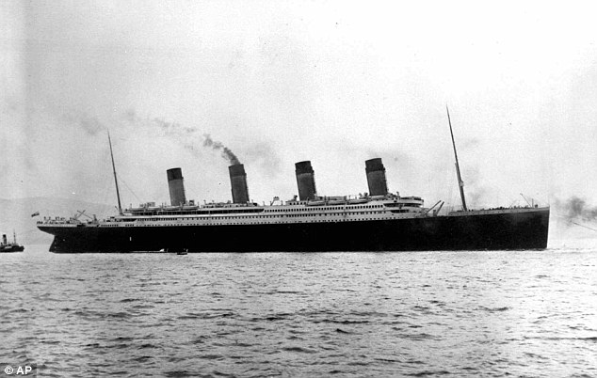

**Iceberg Ahead!**

**PSHE  
Growing and changing**In this unit, Year 1 and 2 will be talking about helping other people, how to be a good friend and respecting each other’s privacy.