

Naseby Primary Academy  
Sports Premium & PE Plan 2021 - 2022

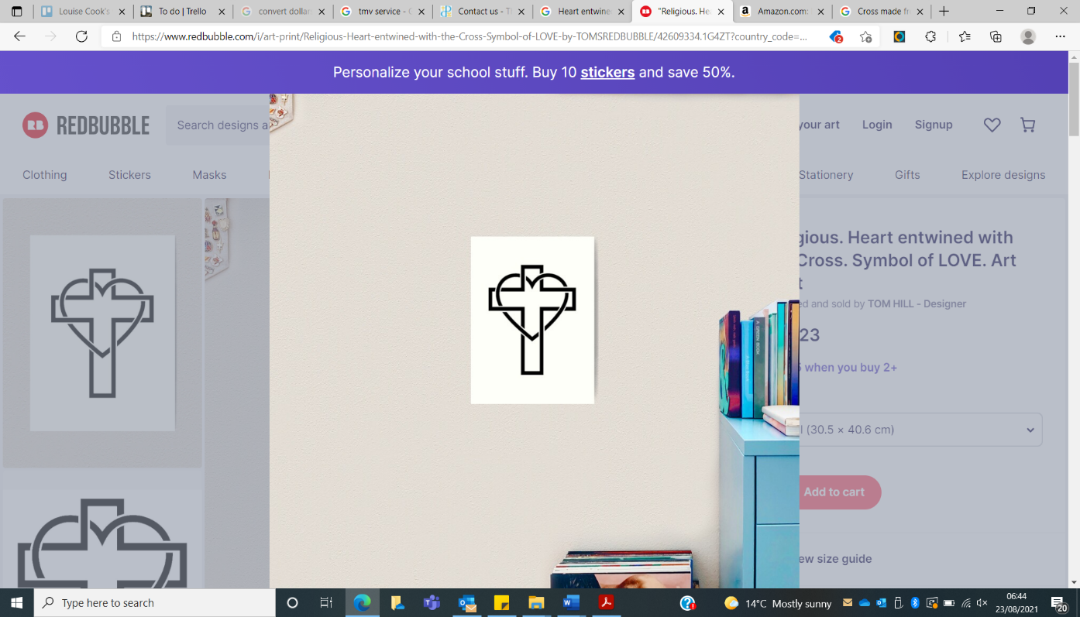

|  |  |  |  |  |
| --- | --- | --- | --- | --- |
| **Academic Year: 2021/22** | **Total fund allocated: £16729.71** | **Date Updated: 03/02/22** | |  |
| **Key indicator 1: The engagement of all pupils in regular physical activity – Chief Medical Officer guidelines recommend that primary school children undertake at least 30 minutes of physical activity a day in school** | | | | **Percentage of total allocation:** |
| **8.7%** |
| School focus with clarity on intended **impact on pupils**: | Actions to achieve: | Funding allocated: | Evidence and impact: | Sustainability and suggested next steps: |
| PE  Develop Leadership skills for Year 5 & 6.  (Delivered by Pacesetter)  Seasonal Walk every half term from March onwards as weather improves and conditions are safer.  Provide additional Swimming provision for KS2 children and to meet the standards of the national curriculum. | School have 2 hours/sessions scheduled every week.  Year 5 & 6 to design, plan and deliver their own sessions from March 22 onwards.  Exercising for a morning taking in the sights of Naseby.  Hire of the pool, swimming coach and transport. | N/A  £1,300  £160 – Hi Vis safety  Awaiting cost update from April 2022 for Summer term | 2 sessions of quality PE. Everyone active.  Small groups for PE, more specialised coaching. Coach to observe and assess each Year 5 & 6 sessions during January - June.  Exercise and positive impact on Wellbeing.  Be able to competently use a range of strokes and various skills within the water. | Continuous throughout the year.  Year 5 & 6 children understanding of what’s involved in taking sports sessions.  Certificates for the winning finalists & runners up.  Linked to topics/values/seasonal themes. Children to understand the importance of exercise outdoors & impact of nature on, mental health and wellbeing.  By the time children leave Year 6 to be able to swim 25 metres. |
| **Key indicator 2: The profile of PESSPA being raised across the school as a tool for whole school improvement** | | | | **Percentage of total allocation:** |
| **16.3%** |
| School focus with clarity on intended **impact on pupils**: | Actions to achieve: | Funding allocated: | Evidence and impact: | Sustainability and suggested next steps: |
| Tournaments in school  (Delivered by Pacesetter)  Tournaments (as above) - trophies and certificates  Sports Newsletter  (Delivered by Pacesetter)  Additional planning, admin and resources in all of the areas mentioned to further enhance and develop PE and Sport at Naseby C of E Primary Academy.  PE Map Grading  Magnificent Minds Well-Being Course & Playmaker Award for pupils  Pacesetter Sports & Wellbeing Award 2021-22 | All children from Years 1-6 taking part in competitive matches including SEN. 6 Sports throughout the year in line with PE topic.  Engraved trophies for winning class team. Certificates for children demonstrating sportsmanship qualities and school values.  Information to parents regarding sports and activities relating to PE, clubs, competitions and other events.    Making sure children, parents and teachers are getting the most out of sport and PE. Achieve a positive culture around sport and giving children maximum choice and opportunity.  Each child gets graded on the first session based on overall ability and then gets graded during the topic against certain skills within each session. The matrix will then add up these grades and will give an overall score based on ‘High Achiever’, ‘Achiever’ or ‘Low Achiever’  To promote positive mental health related messages across the school through; 1 day of Magnificent Mind Champion Training for Year 5 pupils & PlayMaker Award introducing Year 5 pupils to leading activities during break times, giving learners the knowledge and skill to organise small games and activities.  Certificate demonstrating the School’s commitment to • Quality of PE & School Sport • LEVEL 1 - Internal (House/Class) School Competitions • LEVEL 2 - Inter School Competitions & Fixtures • LEVEL 3 - County/regional/national representation by school team or individual (KS2) • Extra curricular clubs • Young leaders involvement • Links to outside clubs and agencies • Wellbeing and work with children’s mental health. | £200  £148  £100  £1280  £200  £800  No cost associated with this | Wellbeing and growth mindset, competition, sportsmanship and co-operation. Trophies for winning team.  Children feedback and positivity around competition.  Newsletter mailed out to parents on the last day of each full term.  Feedback from parents, teachers and children. The amount of children attending internal and external clubs.  This will give a clear and measurable way to analyze performance and ability Levels.  Promotion of positive mental health messages by children.  Support for younger children through activities and games led by Year 5 at break & lunchtimes.  Informative data that can be shared with Governors, parents and wider community. The certificate is unique to Naseby Primary School | Linked to upskilling sports so children will have knowledge of the necessary skills and rules prior to the event. Teachers will be involved so they improve their knowledge on the progressive PE lessons and skills and how tournaments can be run.  These trophies can then be used again for the following year.  Continuous work to provide a variety to parents.  Keep the areas that are working well and that are enhancing children’s experiences. Making changes to those areas that are not working.  These grades can be saved and then a picture of performance and ability levels can be compared year on year.  Resources for games/activities purchased and regular meeting with group review success of activities each half term and plans for improvements as required next ½ term.  Linking Mental Health & well-being activities with national and local initiatives.  The results can be used and compared with future years. |

|  |  |  |  |  |
| --- | --- | --- | --- | --- |
| **Key indicator 3: Increased confidence, knowledge and skills of all staff in teaching PE and sport** | | | | **Percentage of total allocation:** |
| **24%** |
| School focus with clarity on intended  **impact on pupils**: | Actions to achieve: | Funding  allocated: | Evidence and impact: | Sustainability and suggested  next steps: |
| Teachers upskilled in PE Games.  (Delivered by Pacesetter)  Orienteering training in summer term | Mixture of sports to be upskilled  Staff trained in outdoor orienteering activities to improve mental health and well being using the school grounds. | £4032  Awaiting cost following mew prices in April 22 | Using a PE scheme of work written by PE specialists. Children Self-Reflection form at the end of each topic.  Using scheme of work to implement orienteering activities into timetable.  PP/SEND pupils benefit from orienteering activities to improve mental health and wellbeing and support nurture through coping & calming techniques/strategies. | Teachers use and implement plans in the future and become more confident with the key skills and techniques related to these sports.  Orienteering is regular explored by each class as a tool to improve mental health & well being. |
| **Key indicator 4: Broader experience of a range of sports and activities offered to all pupils** | | | | **Percentage of total allocation:** |
| **26.7%** |
| School focus with clarity on intended  **impact on pupils:** | Actions to achieve: | Funding  allocated: | Evidence and impact: | Sustainability and suggested  next steps: |
| Multi Skills Club  (Delivered by Pacesetter)  Two Lunchtime C4L Clubs.  (Delivered by Pacesetter)  After school Football Club  Pre school Gymnastics Club  After School Fun Zone activity Club  After School Club by The Northamptonshire School of Dance  Enrichment Dance opportunity offered to pupils with The Northamptonshire School of Dance – through ‘WOW’ day.    Enrichment opportunity offered to pupils through a ‘WOW’ day of Basketball with a professionally trained basketball player.  Orienteering | Fully funded. Open to all. To include PP and SEN children.  Free access to children during a Monday & Tuesday lunchtime.  Every Monday after school. Part funded enabling greater access and participation. Parents to pay a small contribution.  Every Friday morning before school. Parents pay £4.75 per session  Every Thursday after school to provide a range of sports activities and games that change on a weekly basis; cricket/table/tennis/hockey/  circus skills/Archery/ Parents pay £6 per session  Every Friday after school to provide ‘Street dance’ session with a professionally trained dance teacher – Miss Bette. Parents to pay £6 per session.  Each class experiences learning dance in a professional dance studio with a professional dance teacher. Each class learns a dance to be performed – linked to a story theme.  Whole school assembly to introduce a professionally trained basketball player to talk about her training and career success. For each class to then work with the player to do a training session in Basketball.  Outdoor Orienteering activities to improve mental health and well being using the school grounds. | £1710  £2016  £748  N/A  N/A  N/A  Awaiting cost  Awaiting cost  Awaiting cost | Participation. Evidence through the participation tracker. This tool can identify how many children are assessing extra curricular clubs.  Whole school participating in supervised sport. Wellbeing of children.  Participation. Feedback from children and parents.  Participation. Feedback from children and parents  Participation. Feedback from children and parents  Participation. Feedback from children and parents. Raise the profile of Dance in school.  Whole school participation and performance to parents. Children improve co-oridnation, raise self esteem and confidence through enjoyment of dance.  Whole school participation in Basketball as a career talk by a professional female basketball player. Training session inspires children to take up the sport for enjoyment, fitness and with a view training professionally in the future.  Whole school participation in outdoor orienteering activities to develop team building skills, raise self esteem and confidence to improve mental health and well being through learning outside. | Children improving their skills and attendance levels remain positive.  Keep changing sports across C4L themes.  Numbers to grow over the course of the year. Children to take part in football matches inside school and also part of outside clubs.  Numbers to grow over the course of the year. Children to have link to outside club.  Feedback identifies activities/games children want to cover to provide preferences in future.  More children develop an understanding, passion and love of dance to support mental health & well being and fitness.  Children want to continue dance as a form of enjoyment and fitness.  Success of basketball sessions leads to after school basketball club and school team.  Orienteering activities become a regular part of curriculum and has positive impact on mental health and well being. |
| **Key indicator 5: Increased participation in competitive sport** | | | | **Percentage of total allocation:** |
| **5.3%** |
| School focus with clarity on intended  **impact on pupils**: | Actions to achieve: | Funding  allocated: | Evidence and impact: | Sustainability and suggested  next steps: |
| External Competitions.    School matches to be organised with partner schools. Home matches at Naseby C of E Primary School.  (Delivered by Pacesetter)  Organize Local Club Partnerships.  (Delivered by Pacesetter)  Increased attendance of disadvantaged children at sporting external competitions. | Provide a variety of competitions spanning Reception – Year 6. 14 competitions.  Organise with local schools either after school or during the day.  Assemblies and/or links that can be communicated via the school to the parents.  Children chosen to take part in clubs and competitions based on PP & SEN status | £490 (entry fees)  Part of the Tournament Club Cost  £200  N/A | Giving opportunities for every year group in the following sports; Football, Girls only football, Quicksticks, Athletics, Cross Country, Gymnastics, Multi-Skills, Cricket.  Giving opportunities to children that want to take part against other schools.  A pathway from PE and inter school clubs through to sports clubs outside of school.  When making decisions about teams and clubs PP and SEN children taken into account. | This is sustainable with support from funded transport offered by The Wilson Foundation. Although participation is restricted if no transport, on the whole parents try their best to support.  Organise further competitions.  Children to continue to play and enter games and competitions.  Integrating these children working together. |