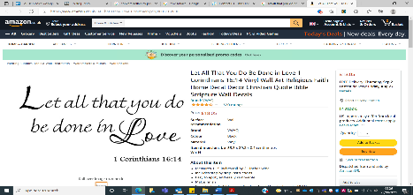
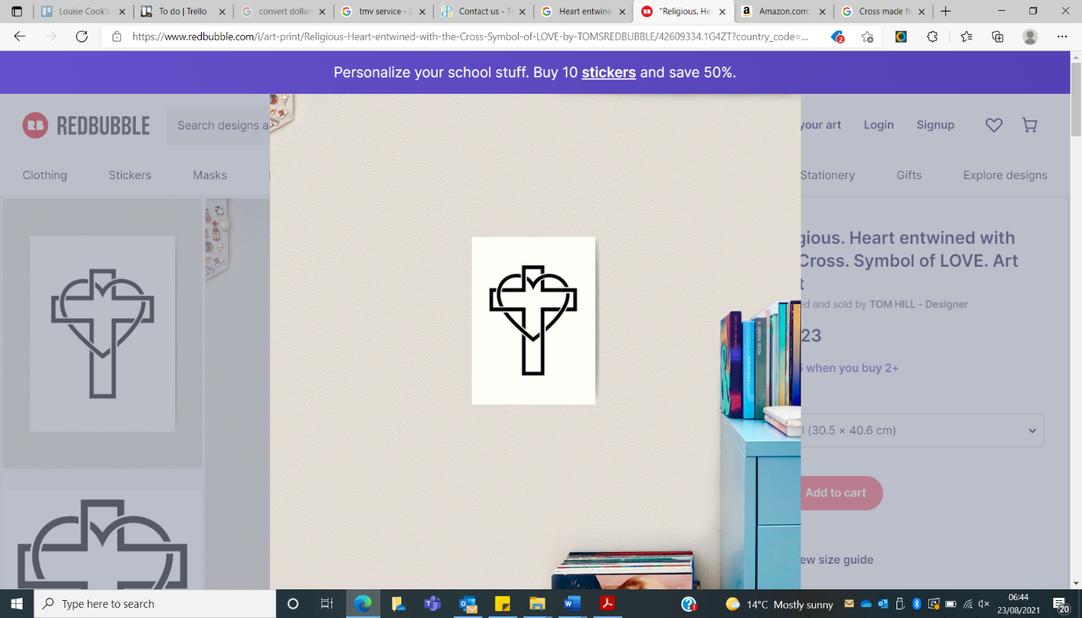
Naseby C of E Primary Academy
Topic Overview for 2022/23
Class | Autumn 1 | Autumn 2 | Spring 1 | Spring 2 | Summer 1 | Summer 2
 |  |  |  | Whole School Topics
Fantastic Fox Cubs  (EYFS & Year 1) | This is me!  Changes in living memory  Animals & Humans | Raise the drawbridge!  Significant Historical events  Investigations | Let’s Explore  Significant Individuals  (Grace Darling& Zora Neale Huston)  Location Knowledge  Geographical Skills & Fieldwork  Materials | Amazing Artists  Significant Individuals  Seasonal Changes | Battle of Naseby 1645  Significant Historical events  Geographical Skills & Fieldwork | 180th Anniversary of Naseby School  Significant Historical events
Busy Badgers  (Yrs 2, 3 & 4) | Lights, Camera, Action!  Significant Historical events  Electricity | Non-European Society  UK & Other country comparison to include Xmas around the world  (Mayan? Aztecs? Chocolate topic?)  Sound | Anglo Saxons & Scots  Significant Historical events  Location Knowledge  Animals including humans | Amazing Artists  Significant Individuals  Living things & their habitats | Battle of Naseby 1645  Significant Historical events  Geographical Skills & Fieldwork  States of Matter | 180th Anniversary of Naseby School  Significant Historical events  Light
Wise Wolves  (Yrs 5 & 6) | U.S.A.  Location & Place Knowledge  Geographical skills & Fieldwork  Light | Romans  Significant Historical events  Geographical skills & Fieldwork  Properties & materials | Shang Dynasty  Significant Individuals & Historical events  Location Knowledge  Forces & Magnets | Amazing Artists  Significant Individuals  Electricity | Battle of Naseby 1645  Significant Historical events  Geographical Skills & Fieldwork | 180th Anniversary of Naseby School  Significant Historical events
Subject Key; (National Curriculum Programme of Study to be covered through the topic, for year groups specified in the class)
Geography History Science

Naseby C of E Primary Academy
Topic Overview for 2023/24
Class | Autumn 1 | Autumn 2 | Spring 1 | Spring 2 | Summer 1 | Summer 2
 |  |  | Whole School |  |  | Whole School
Fantastic Fox Cubs  (EYFS & Year 1) | Marvellous Me!  Changes in living memory  Animals & Humans | Great Fire of London  Significant Historical events  Everyday Materials | Cobblers  (Northampton shoes)  Significant Historical events  Location Knowledge  Geographical Skills & Fieldwork  Materials | Planet Protectors  Location Knowledge  Geographical Skills & Fieldwork  Plants | Space  Significant Historical events & individuals  Seasonal Changes | Going for Gold  (Olympics)  Significant Historical events & individuals  Geographical Skills & Fieldwork  Forces & Materials
Busy Badgers  (Yrs 2, 3 & 4) | Stone Age-Iron Age  Significant Historical events  Rocks | WW2  Significant Historical events  Location Knowledge  Geographical Skills & Fieldwork |  | Anglo Saxons, & Vikings  Significant Historical events  Location Knowledge  Animals including humans | Indus Valley  Significant Historical events  Location Knowledge  Geographical Skills & Fieldwork  Plants
Wise Wolves  (Yrs 5 & 6) | Ancient Egypt  Significant Historical events  Location Knowledge  Geographical Skills & Fieldwork  Living things | Amazing Individuals  Significant individuals beyond 1066  Evolution & Inheritance |  | Extreme Earth  Significant Individuals & Historical events  Earth & Space | Evolving Britain  Significant Historical events  Everyday Materials
Subject Key; (National Curriculum Programme of Study to be covered through the topic, for year groups specified in the class)
- Geography
- History
- Science

