William Shakespeare was an actor, playwriter, poet and theatre entrepreneur. He lived in Stratford-upon-Avon with 4 brothers and 3 sisters. Unfortunately, 2 of them died before he was born, and he also lived with his parent’s john Shakespeare and Mary Shakespeare. When the two children died William became the oldest and married Anne Hathaway at the age of 18. They had 3 children named Judith, Susanna and hamlet. William acted, wrote plays and was a theatre entrepreneur for a theatre company called lord chamberlain’s men. The theatre was called the globe theatre because it was round like a globe. William wrote different types of plays including tragedies like Romeo and Juliet. History like Henry v and Comedy like twelfth night. One time in the globe theatre an actor missed a shot from a cannon he mounted and the shot hit a wall in the globe theatre. Soon after the mistake, William decided to retire and go back to his family in Stratford-upon-Avon but sadly when he got there in 1611, he died supposedly because of a fever caused by drinking he was 52 when he died.
This is his gravestone.

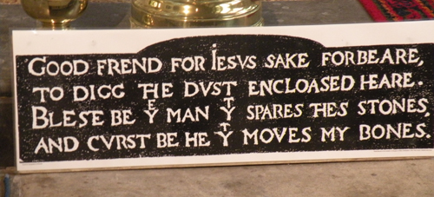
This Photo by Unknown Author is licensed under CC BY-NC-ND

The life of
William Shakespeare

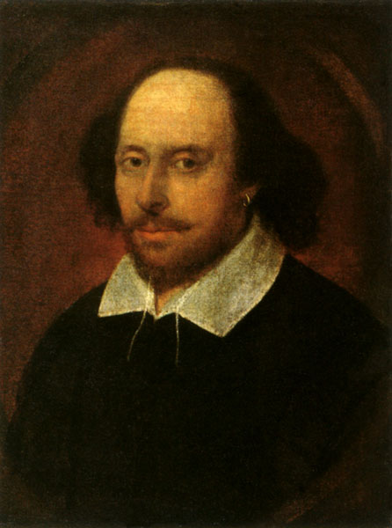
This Photo by Unknown Author is licensed under CC BY-ND

By Corey Ellis

Find out about the amazing life of William Shakespeare!!!

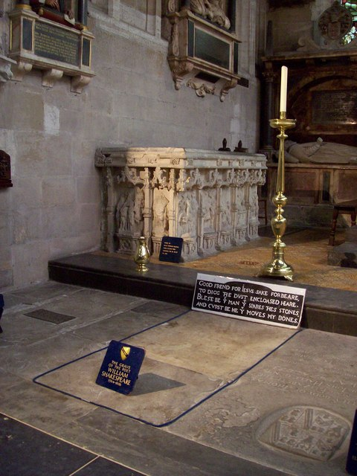
This Photo by Unknown Author is licensed under CC BY-SA

