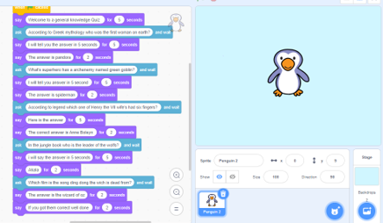
Merryn’s Scratch Quiz - Programming

