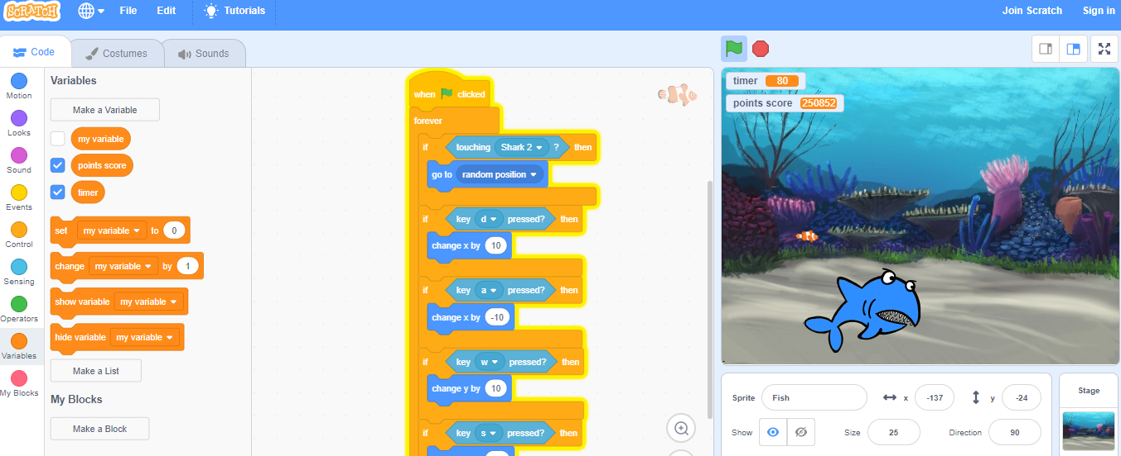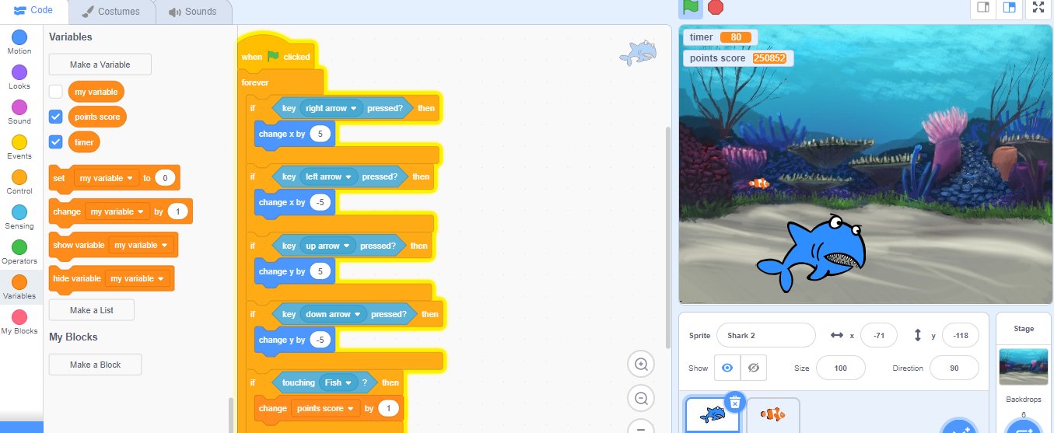

Fish game by Merryn

I have created a game were a shark has to eat a fish. If the fish is eaten it will respawn some were random. If you are the shark you have to try to eat the fish and the fish has to try not be eaten by the shark.