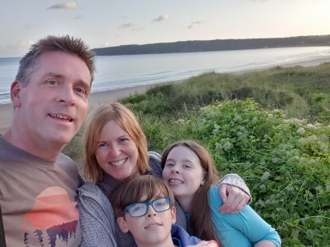

**Inheritance**

I am tall like my daddy

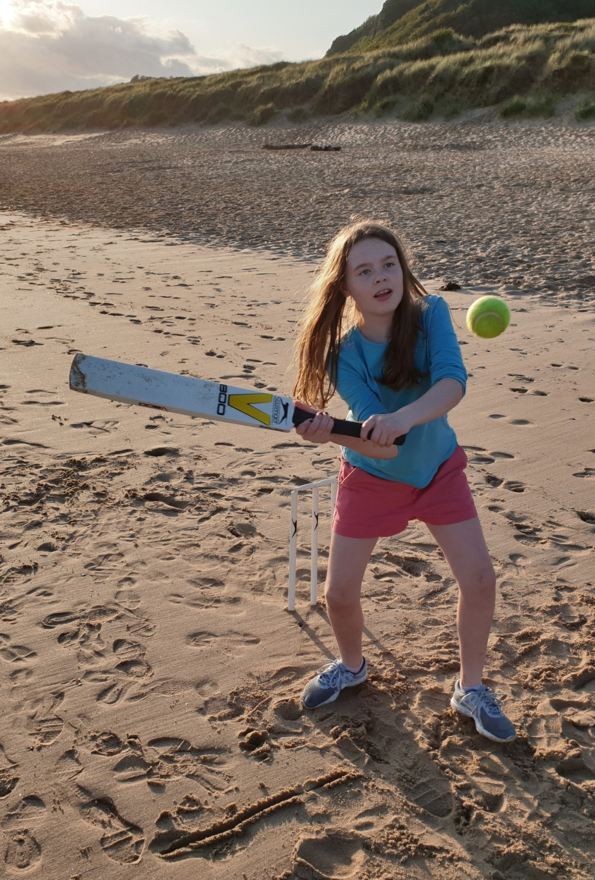

I have my daddy’s hands

I have my daddy’s feet.

I have my daddy’s legs

I have my mummy’s teeth

I have my mummy’s eyes

I have my daddy’s arms

I have my mummy’s lips.

I have my mummy’s nose