Geography/Science

Locate rainforests around the world and find out which continents that they're found in. Find out about the different layers of the rainforest using the PowerPoint on the class webpage.

Complete some research about the animals that inhabit the rainforest and which layer they live in.  You can show your understand by making slides to share with your classmates.

Mathematics

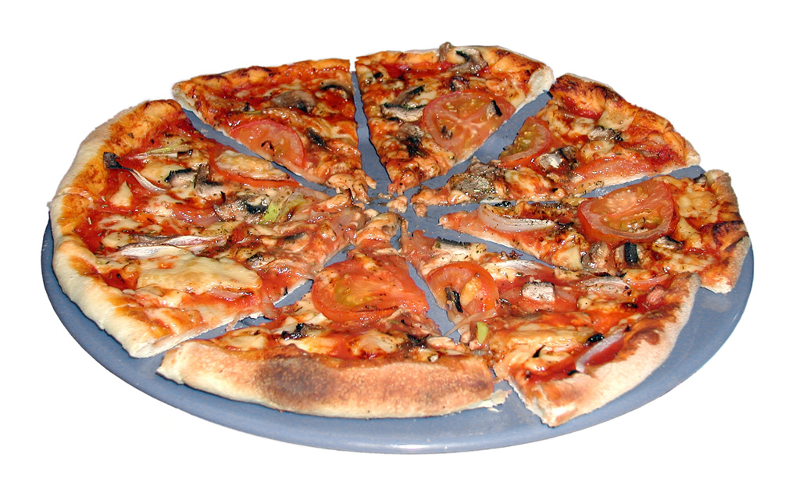

1. Please complete pages from the CGP maths book.

Consolidate understanding of fractions by using real life activities. You could:

* Bake a cake and share it evenly.
* Make a pizza that can help show equivalent fractions.
* Design a quiz to share with your classmates

Be creative! I’m looking forward to seeing the photos.

Reading

I Will upload a reading activity video to the class webpage for this week.



**Class 3 homework**

Topic (ongoing)

Choose one of the following:

* Design and build your own volcano.
* Prepare a PowerPoint presentation about a famous natural disaster.
* Locate famous volcanoes on a world map.

LITERACY/History

Now that you have found out about the life of William Shakespeare, I would like you to carry out some research about life during his time. Explore the Tudor period and discover more about what it was like to be a child during this time and what a Tudor school would have been like.

More information is available here:

<https://www.bbc.co.uk/teach/class-clips-video/introducing-shakespeare/zfr3cqt>